Create a windows Vm machine in AWS and connect with RDP open CMD in windows share the about system info.

- Created Ec2 Instance (windows) in AWS.
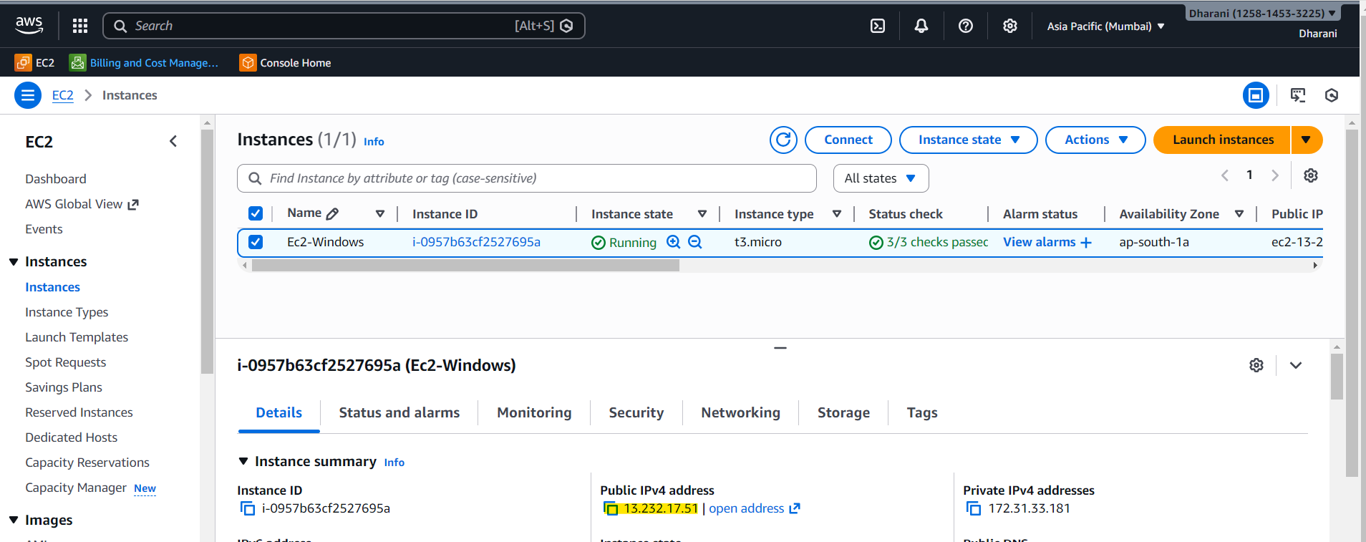

- Connected with RDP
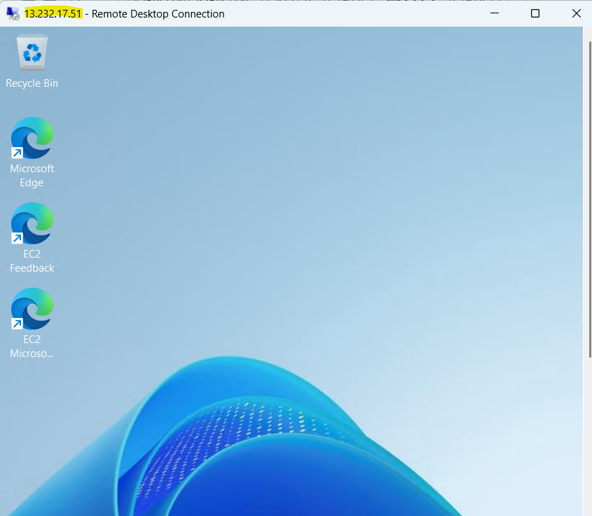
- Opened CMD in windows
